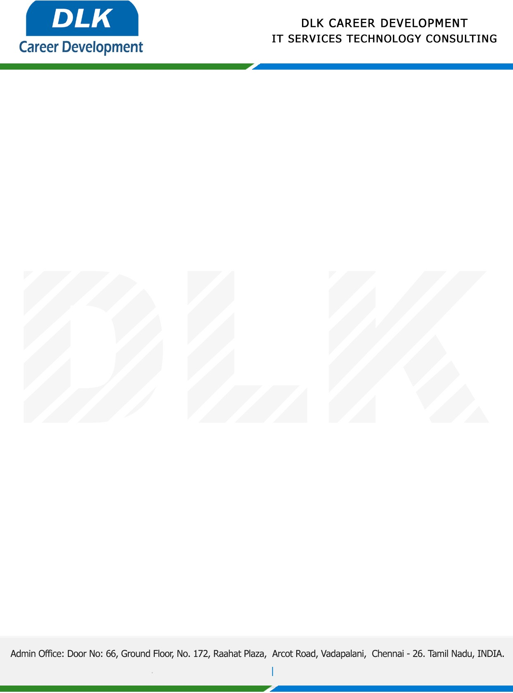

Date: 03 / January / 2023

**To**

Department of MBA - HR, SYSTEMS

Head of Department,

Sathyabama Institute of Science and Technology, Chennai - 600119.

**Sub: Letter of Project Acceptance**

This is to certify that **MR YOGESH KC (REG NO:** **41410350)** that Second year student of has accepted the Project Work duration from **06th January 2023** to **31st March 2023** under the domain **“Human Resources”.** During the Project, all information and data collected from you should be kept confidential.

**TOPIC:** THE EFFECT OF INCENTIVES ON JOB PERFORMANCE IN AN ORGANISATION

We appreciate your interest in **DLK CAREER DEVELOPMENT**

